Object-Oriented Application Development “Reservation System”

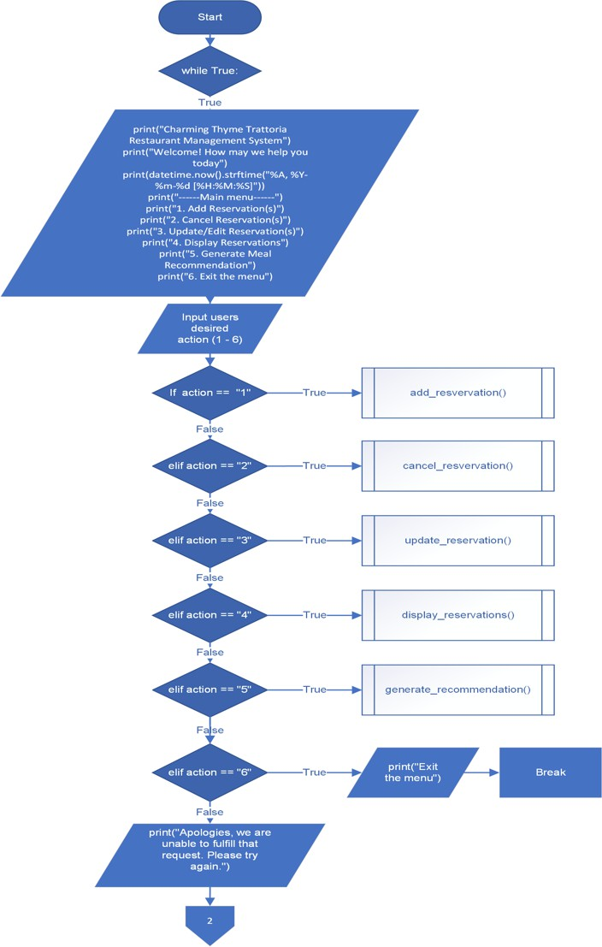

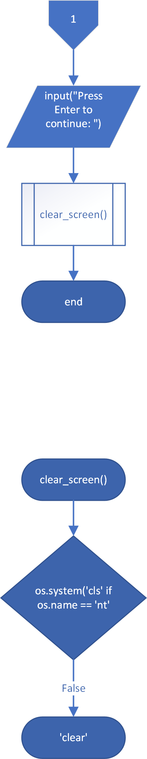

- Add Reservation
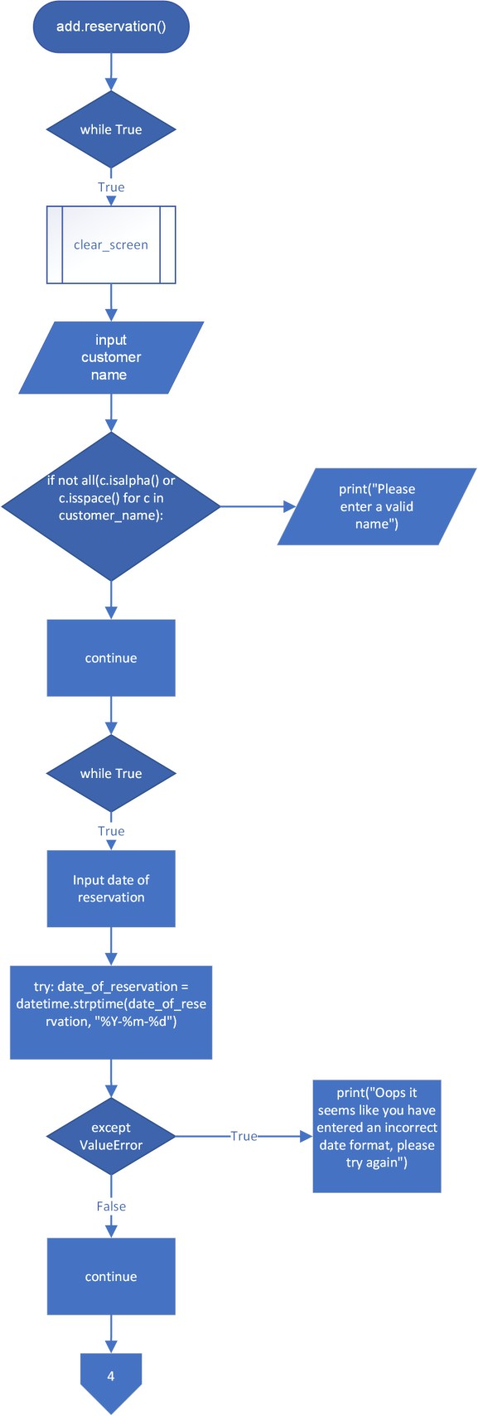

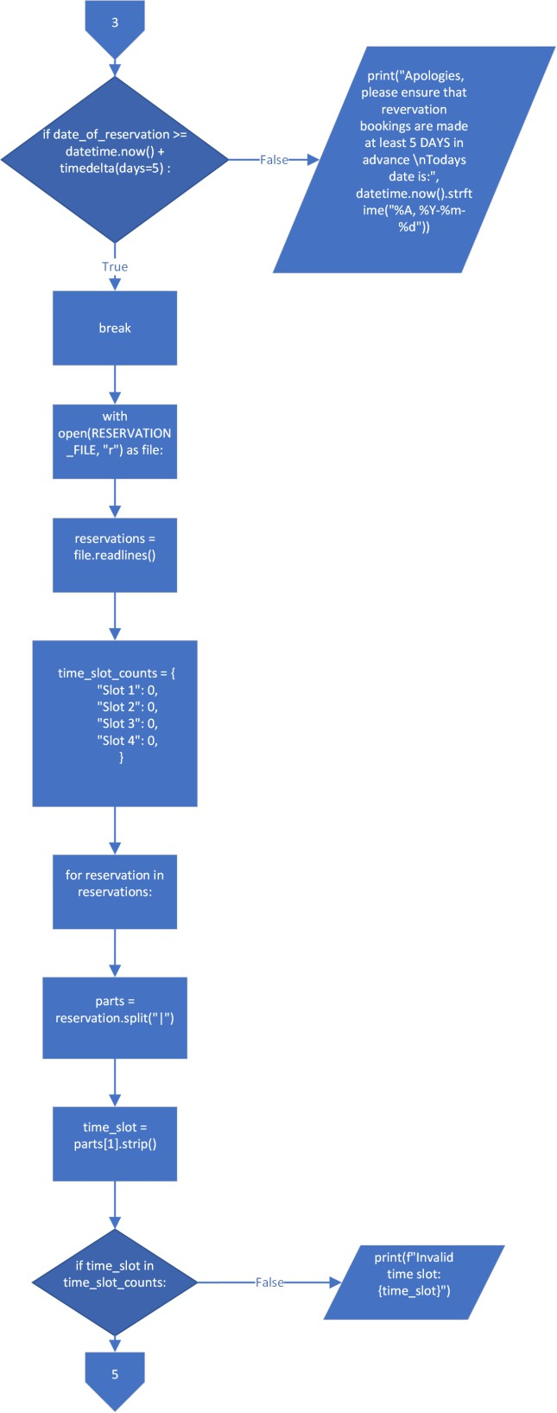

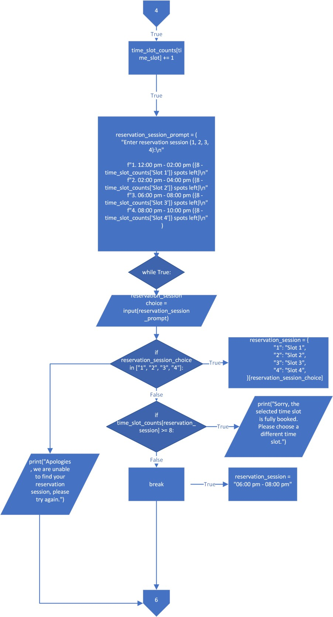

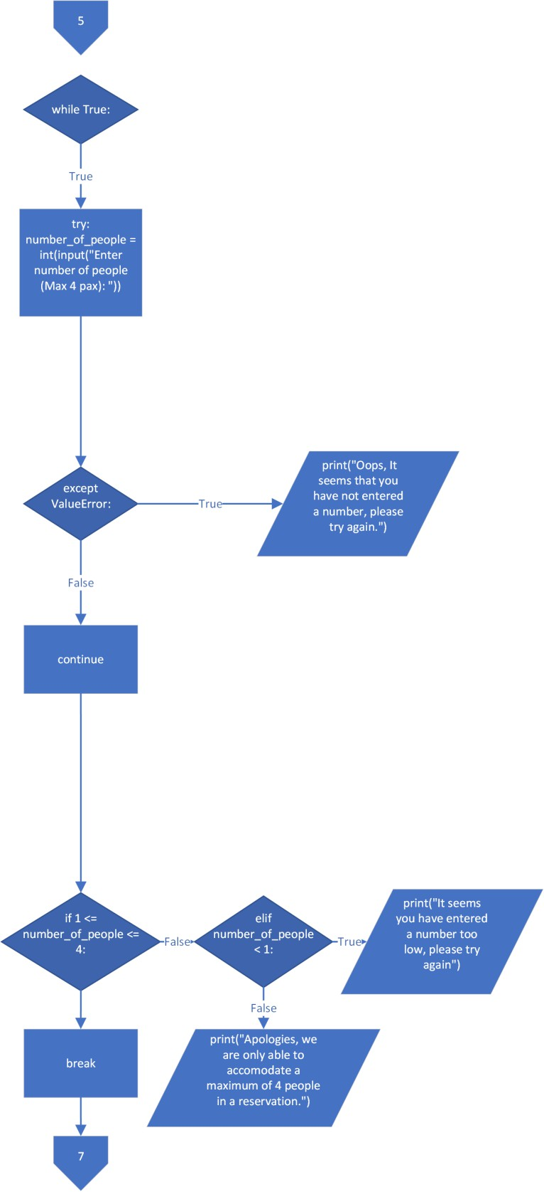

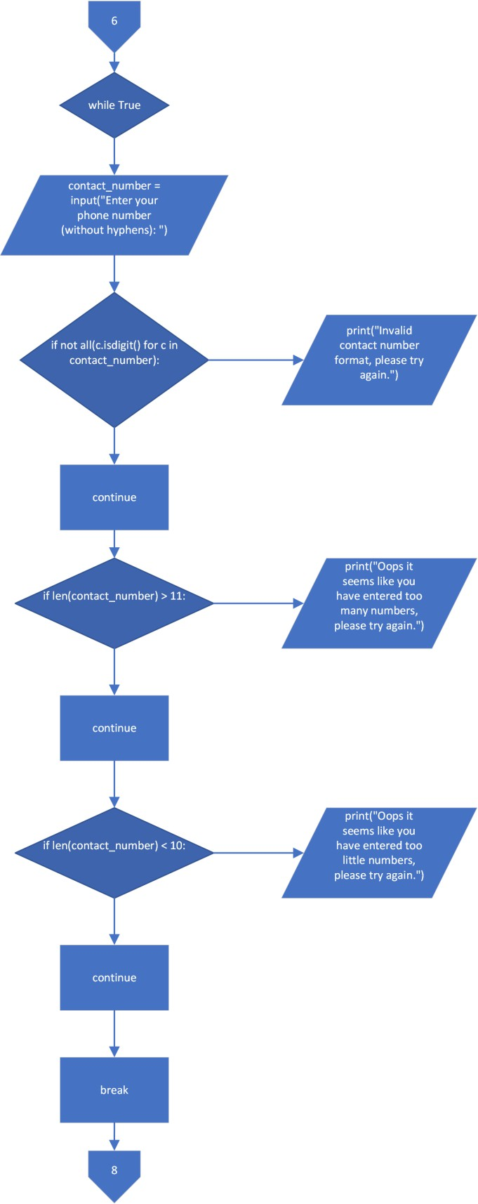

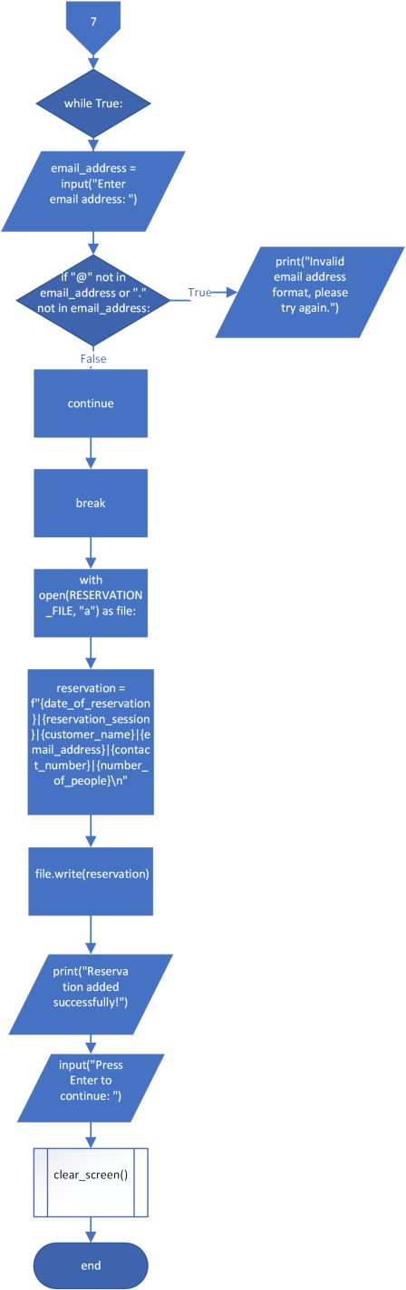

- Cancel Reservation
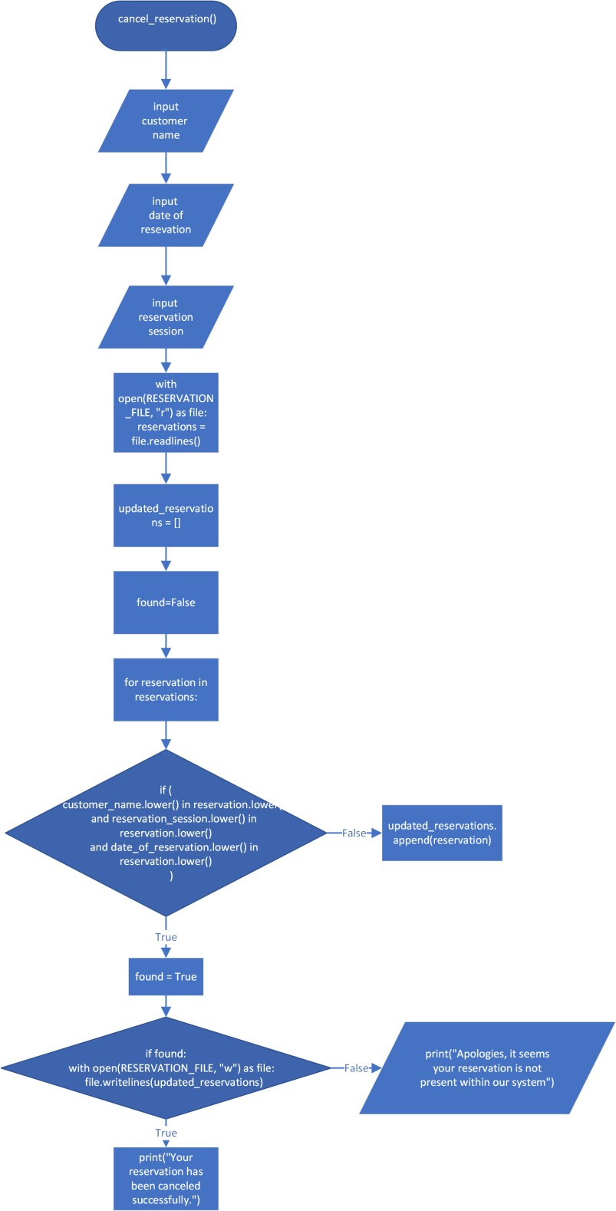

- Update Reservation
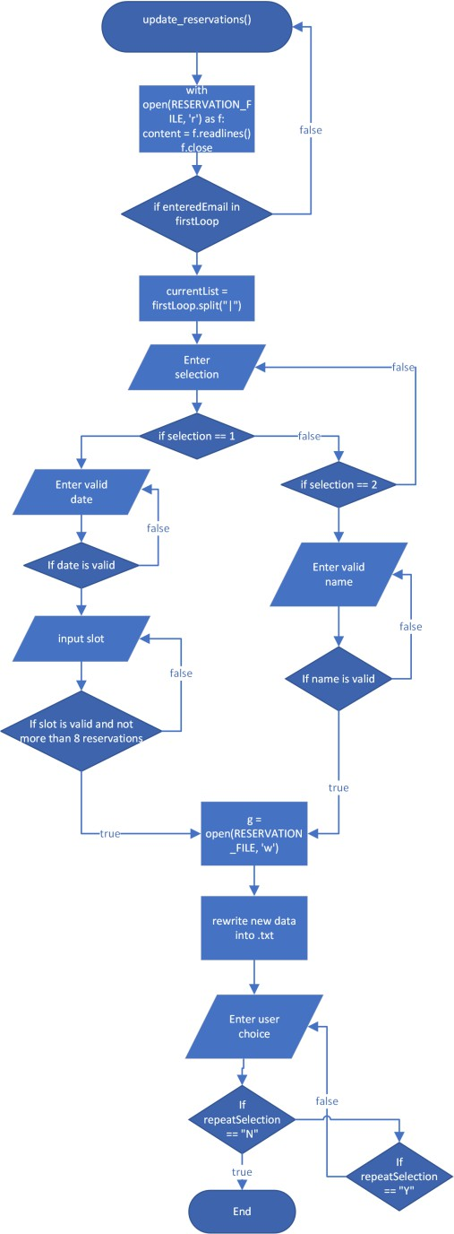

- Display Reservation
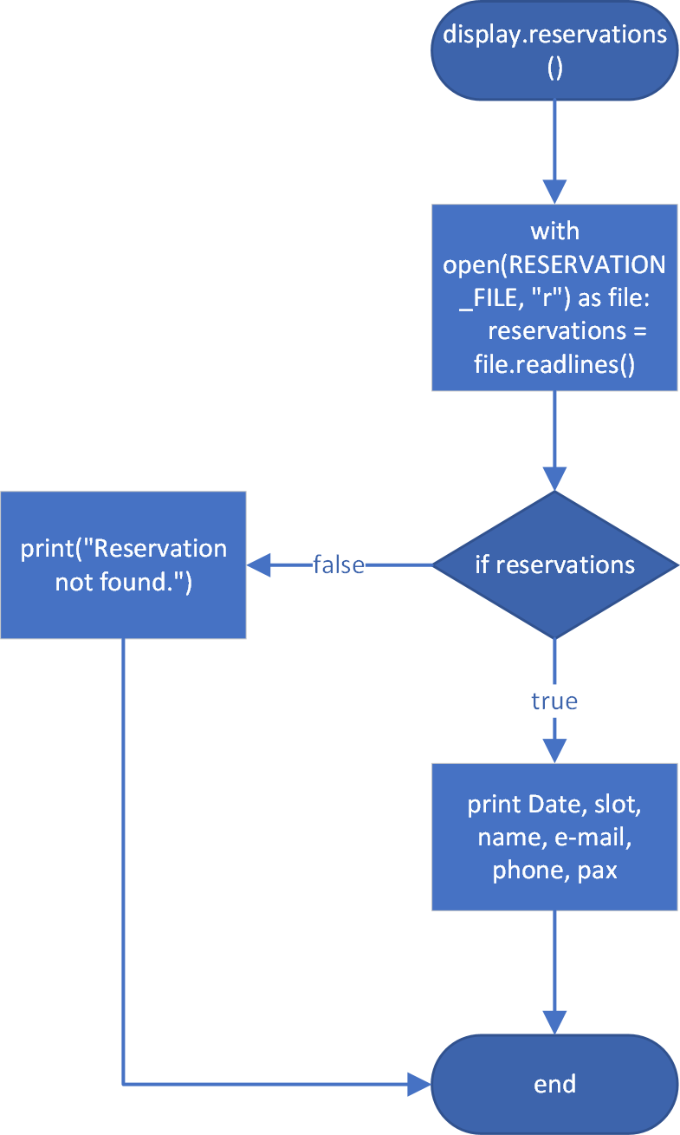

- Discussion on Programming Techniques Used
  - Input and data display
The code uses input() statement to obtain user input for customer details like name, reservation date, session, number of persons, contact number, and email addresses.
The code used print() statement to display reservation information and menu recommendations.

  - Lists and file processing
The code stores data such as menu items and reservation information in
list.
The code reads and writes data from and to text files (.txt) to store reservation information and menu items. It also uses open() and readlines() statement to read and write data from the files into lists.

  - Random choice from a list
The code uses the random.choice() function to randomly select a menu item as a meal recommendation.

  - If statement, and relational and logical operators
The code uses if statements, relational operators like, <, >=, and logical operators like, and, or, to validate user inputs and perform
conditional checks to ensure the correct flow of the program.

  - Loops
The code uses the ‘while’ statement to repeatedly prompt the user for input until a valid data is provided.

  - User-defined function
The code uses several user-defined functions such as add_reservation and cancel_reservation to perform specific tasks, also making the code
more readable.

  - Error Handling and Data Validation
The code uses try-except statements to perform data validation on user inputs and together with conditional checks and loops to ensure the user
input has met the criteria. For example it is used to check whether a reservation is made at least 5 days in advance.

  - Programming Techniques, Logic, and Control Flow
The code uses ‘if’, ‘elif’, else’ and ‘while’, ‘for’ statements to control the flow of the program according to the user inputs and system
conditions. The logical decisions can perform validation on certain conditions to be met by the user input.

- Sample Test Cases and Outputs Task 1 (Add Reservation):
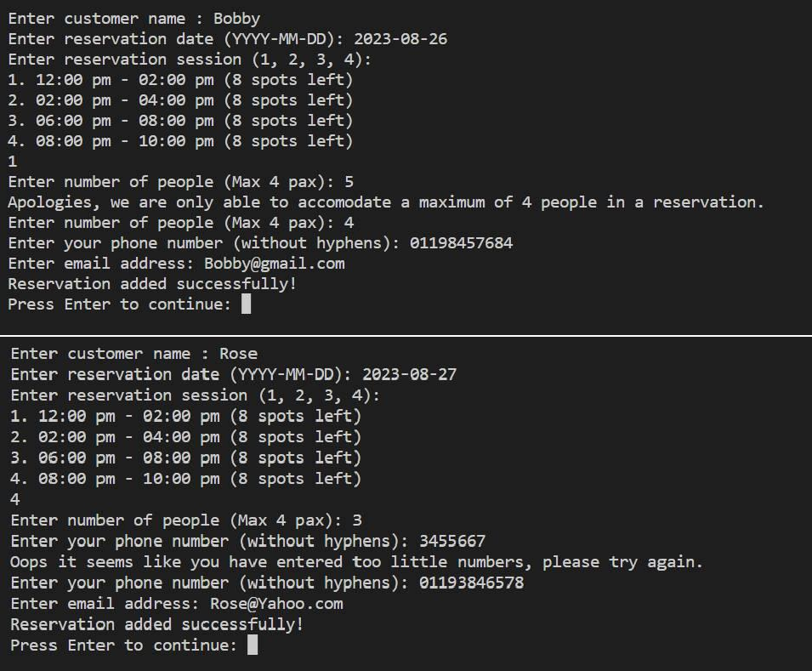

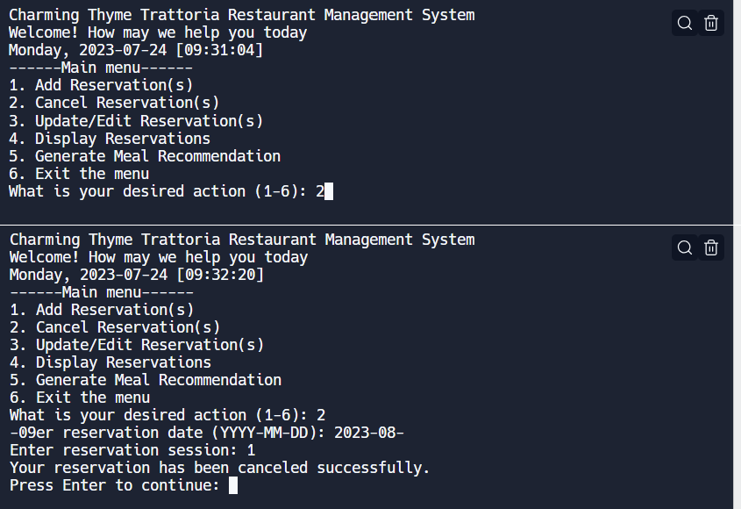
Task 2 (Cancel Reservation):

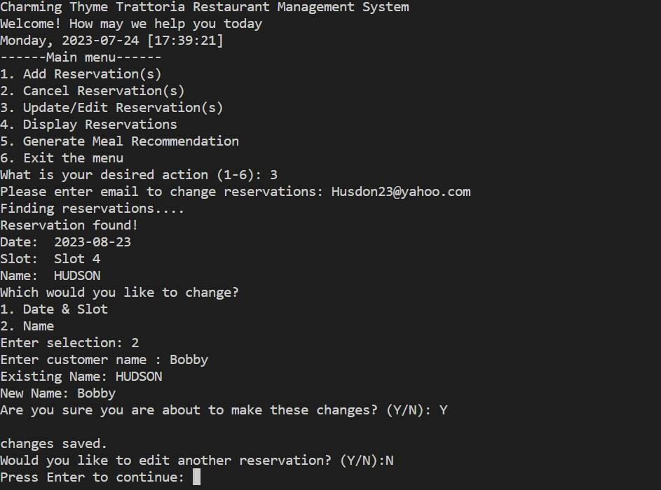
Task 3 (Update/Edit Reservation):

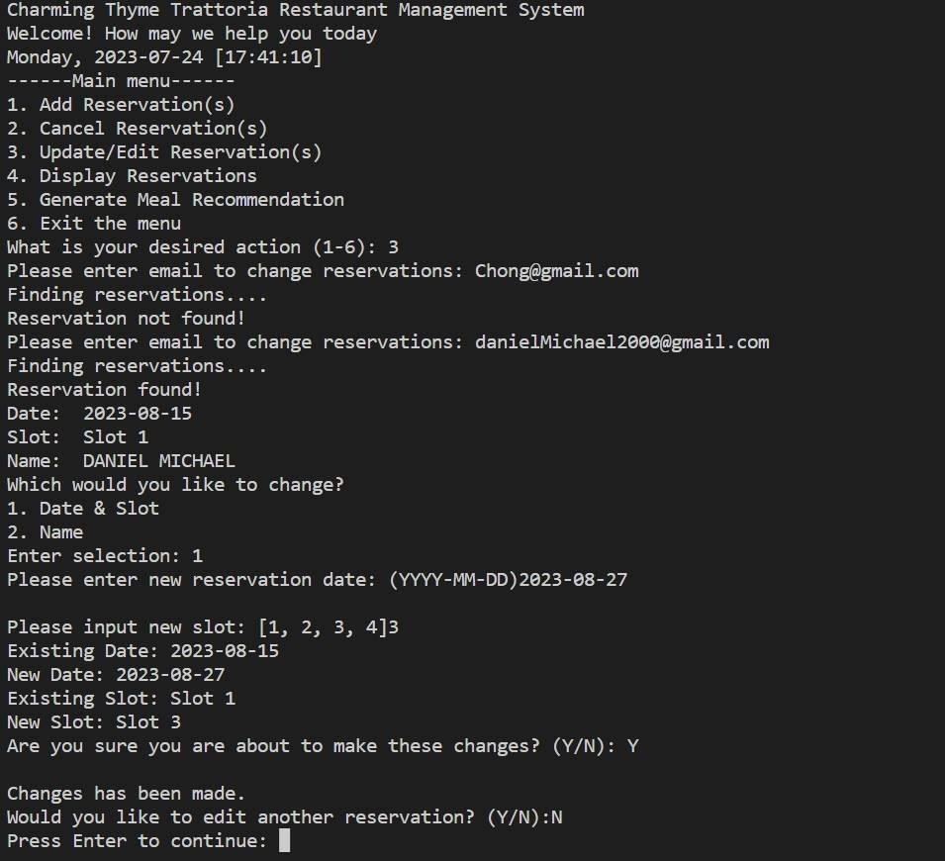

Task 4 (Display):

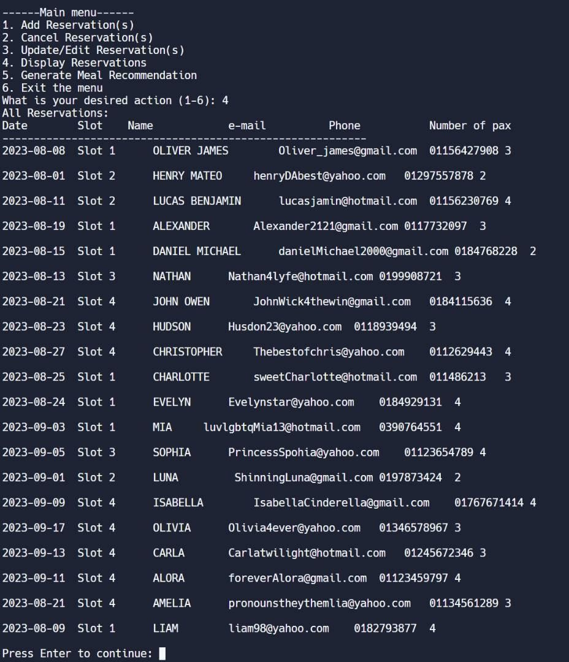

Task 5 (Generate Meal Recommendation):

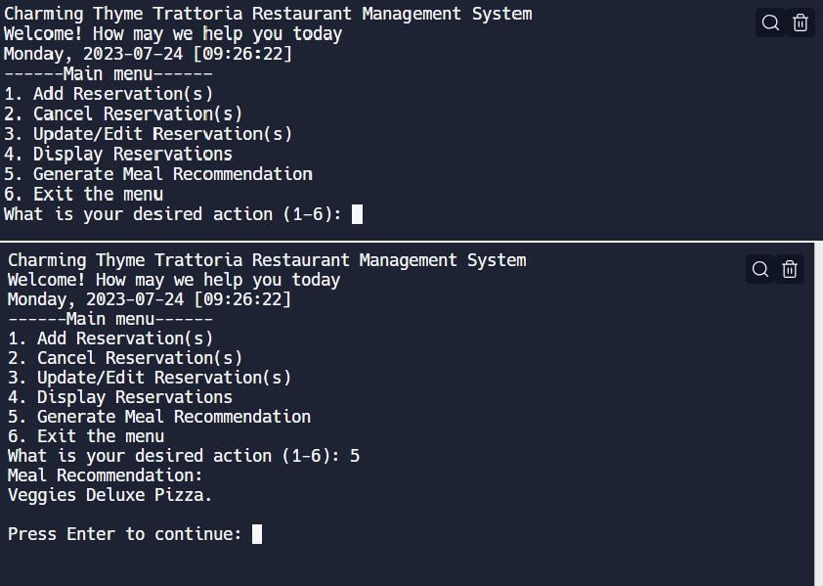

Task 6 (Exit):

